Creating pipeline view in Jenkins

STEP 1:
LOGIN JENKINS->DASHBOARD->NEW ITEM->Enter an item name->NAME->FREESTYLE PROJECT->OK->FOLLOW PRATCICE GUIDELINE STEP 2 OF EXPERIMENT 9

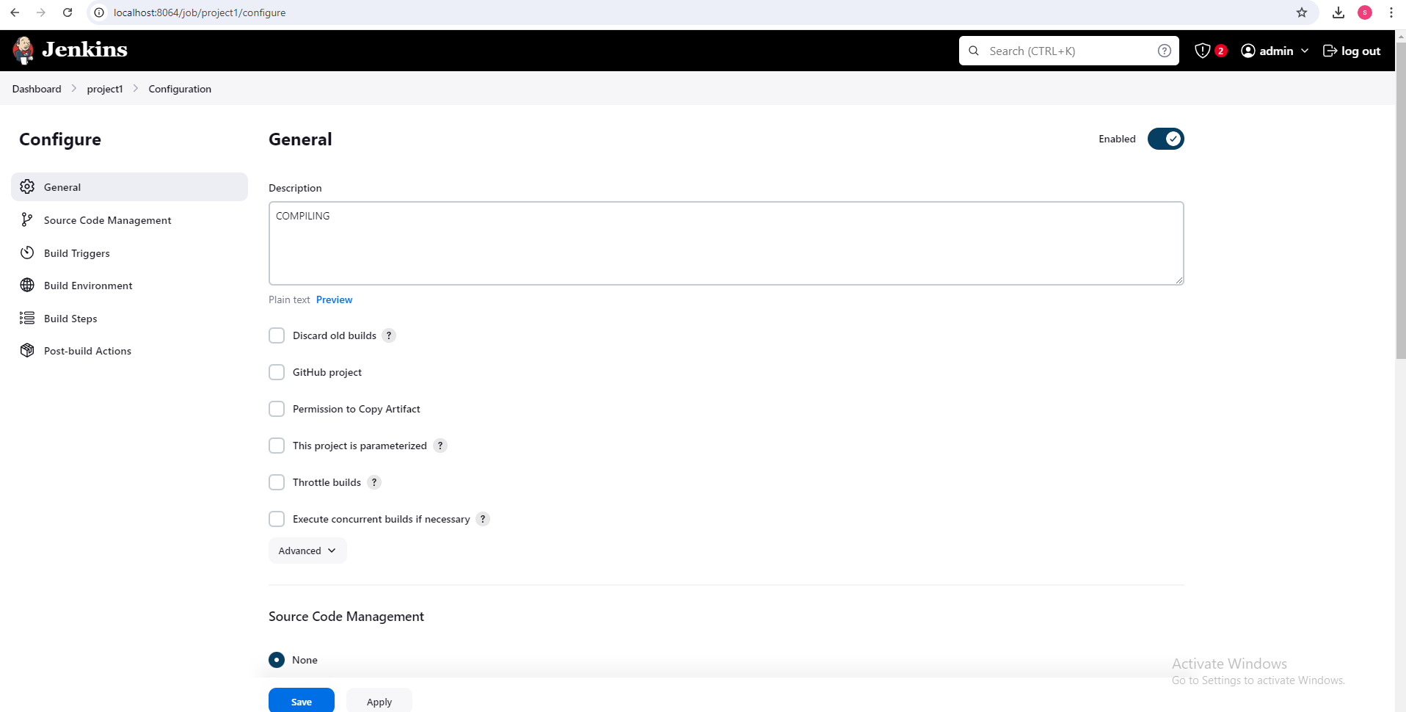

SOURCE CODE MANAGEMENT->COPY GIT REPOSITORY URL AND PASTE

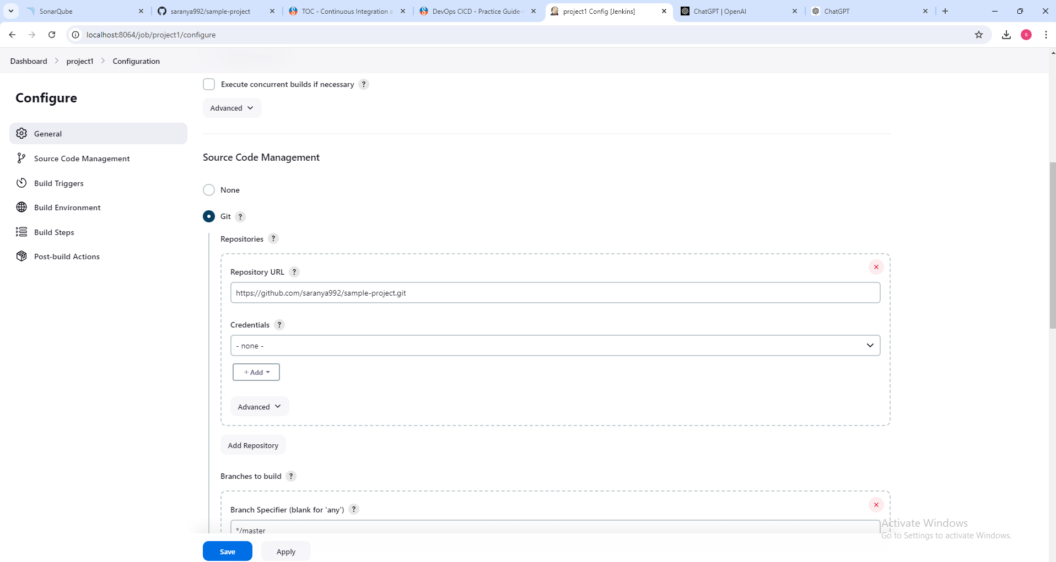

GO TO BUILD STEPS OR ELSE SAVE ->SELECT BUILD(PROJECT BUILD OR EXECUTED SUCESSFULLY)

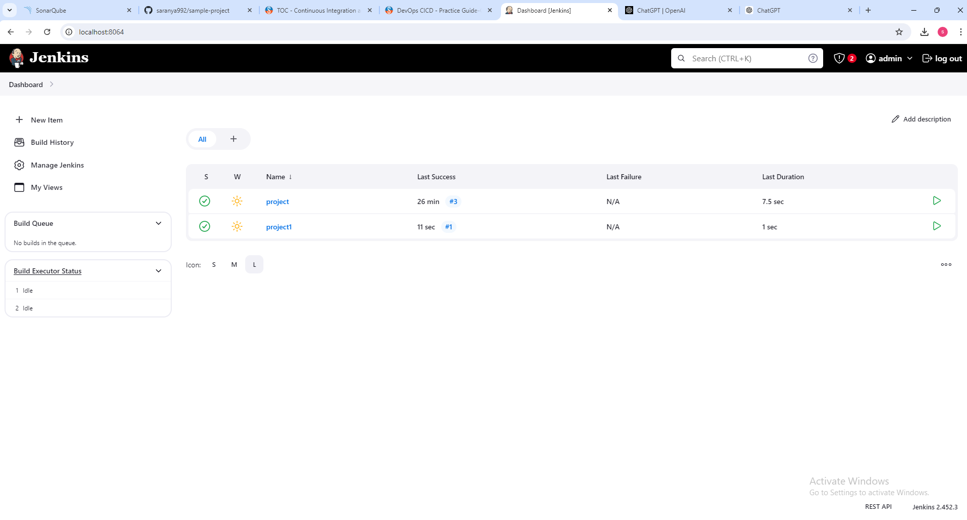

CLICK + IN all OPTION ->GIVE NAME AND CLICK BUILD PIPELINE

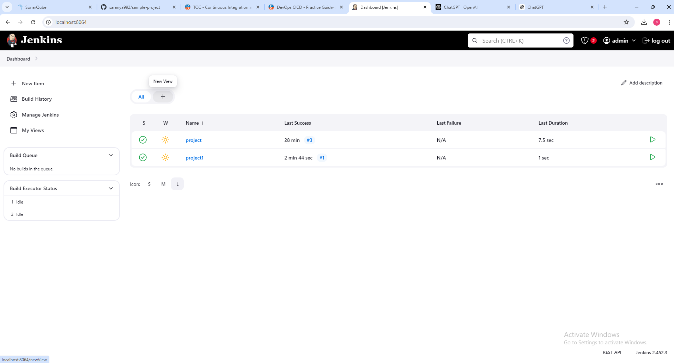

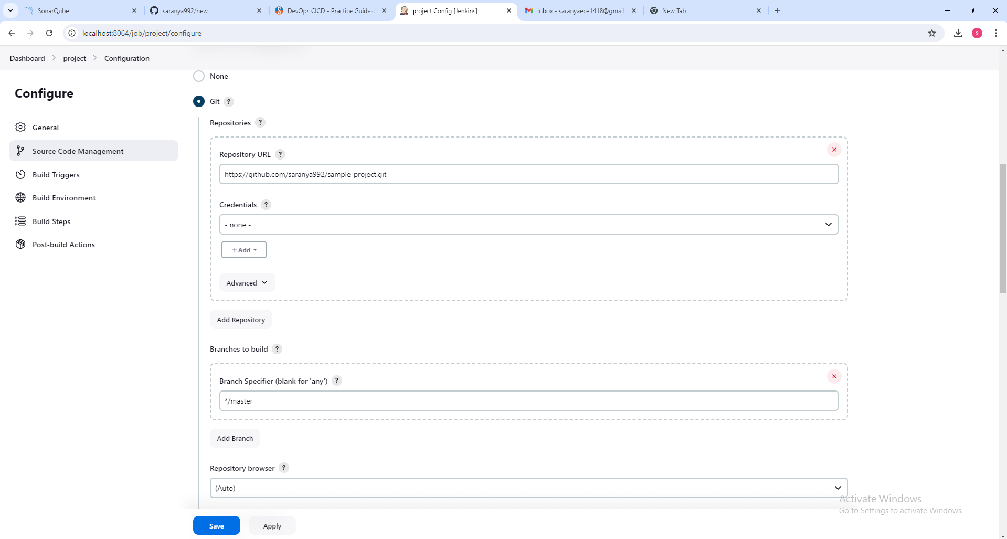
Post-build actions->Projects to build->give previous done file name(compile)->click( Trigger only if build is stable)

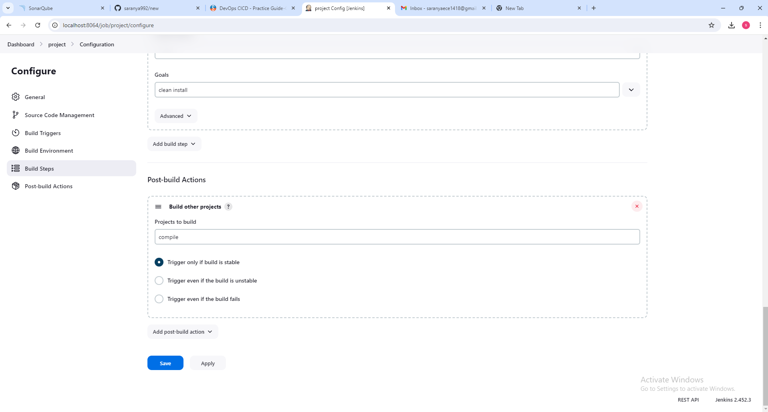
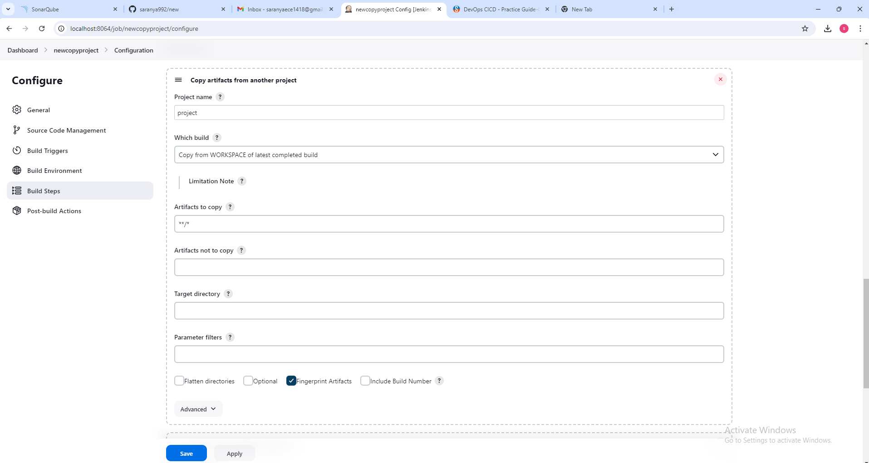
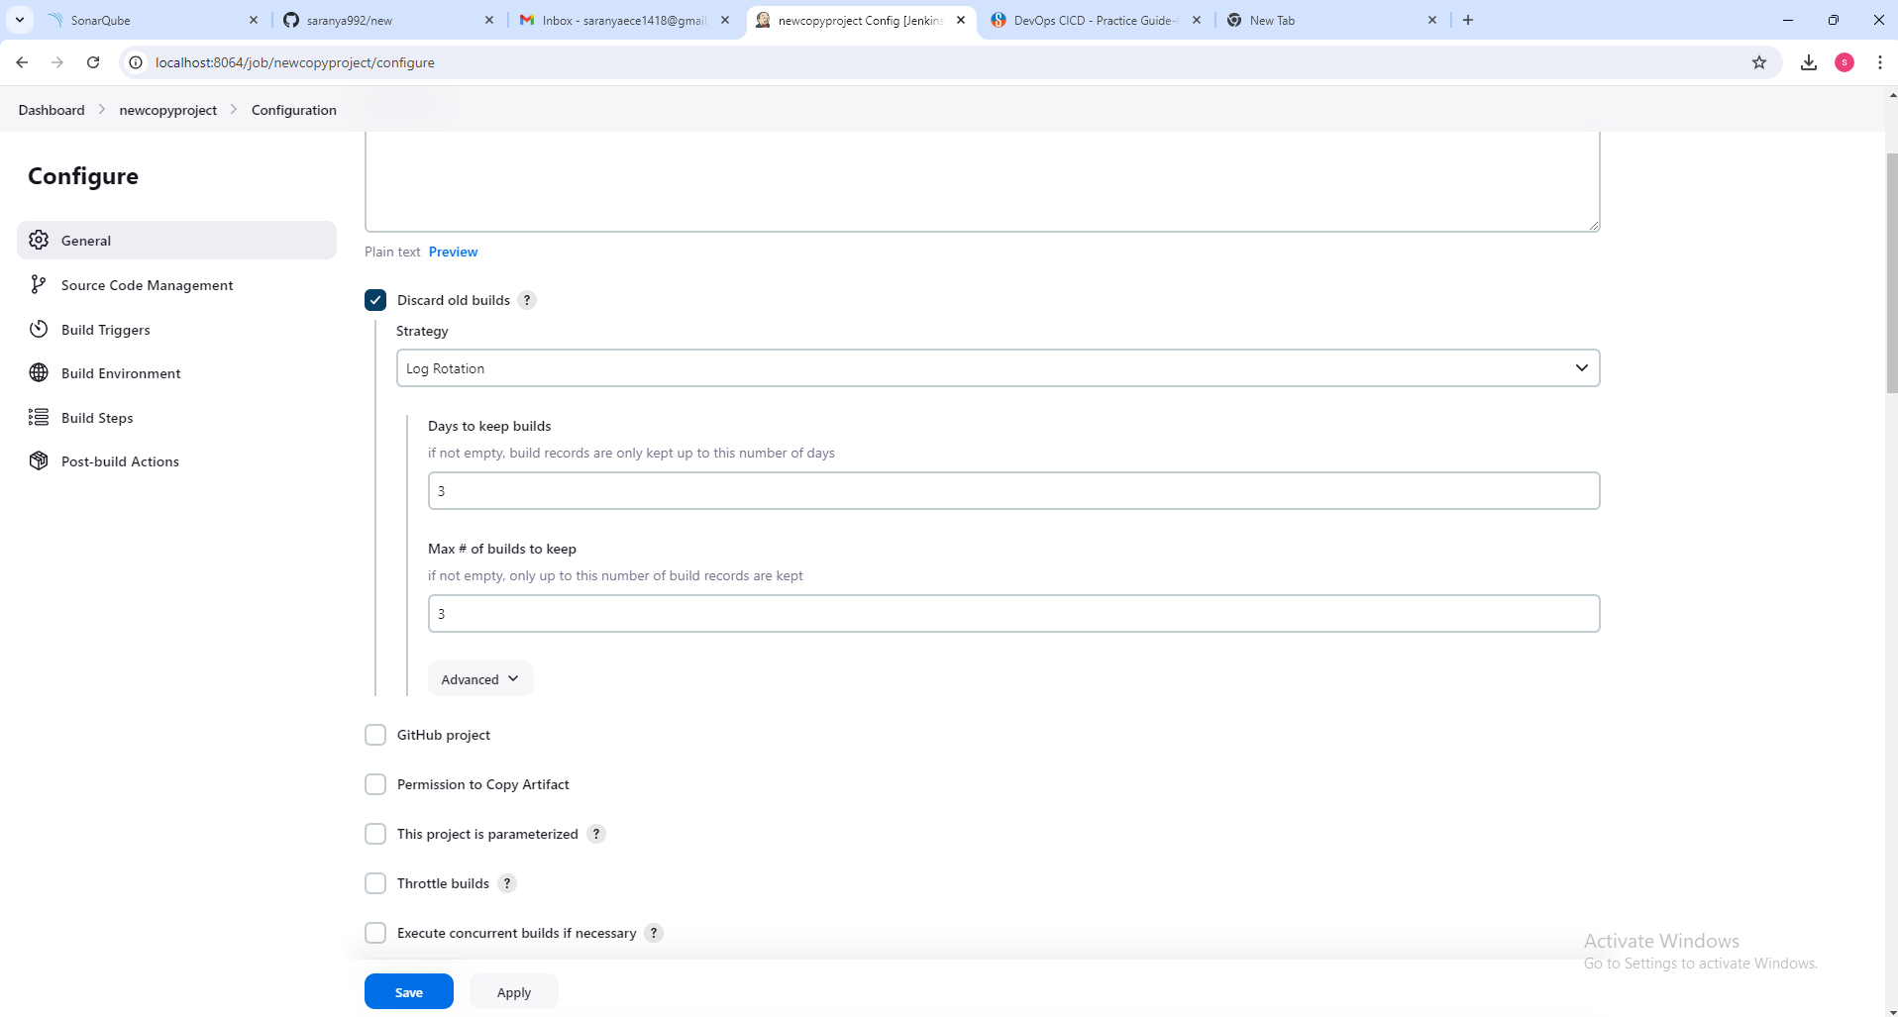
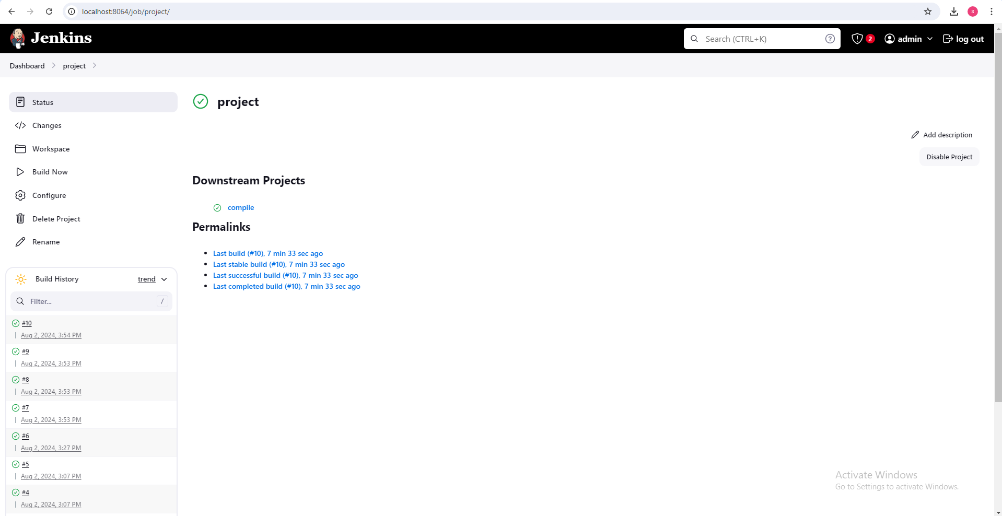

Step 2: Provide the name for the pipeline in the viewname field and select the Build Pipeline View and click create as shown in the screenshot given below.

GO TO Manage Jenkins->Plugins->AVAILABLE PLUGINS->SELECT BUILD PIPELINE->CLICK INSTALL->

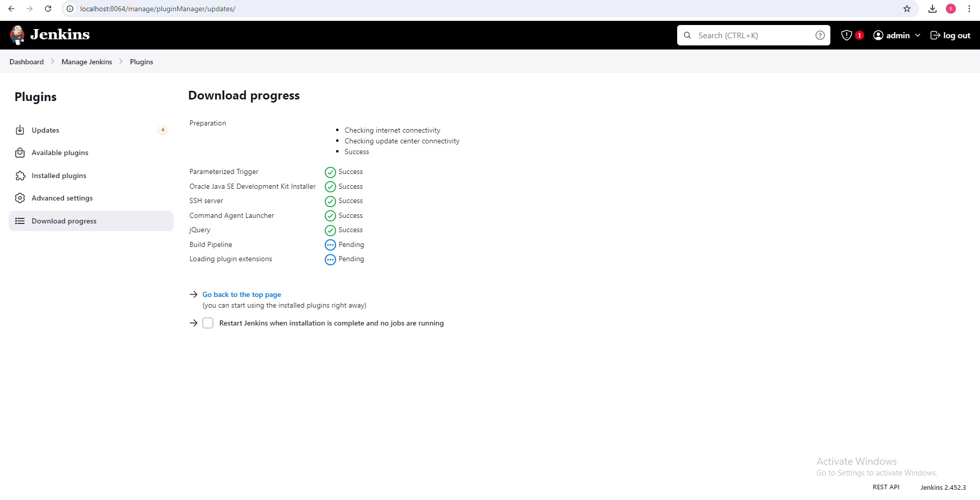
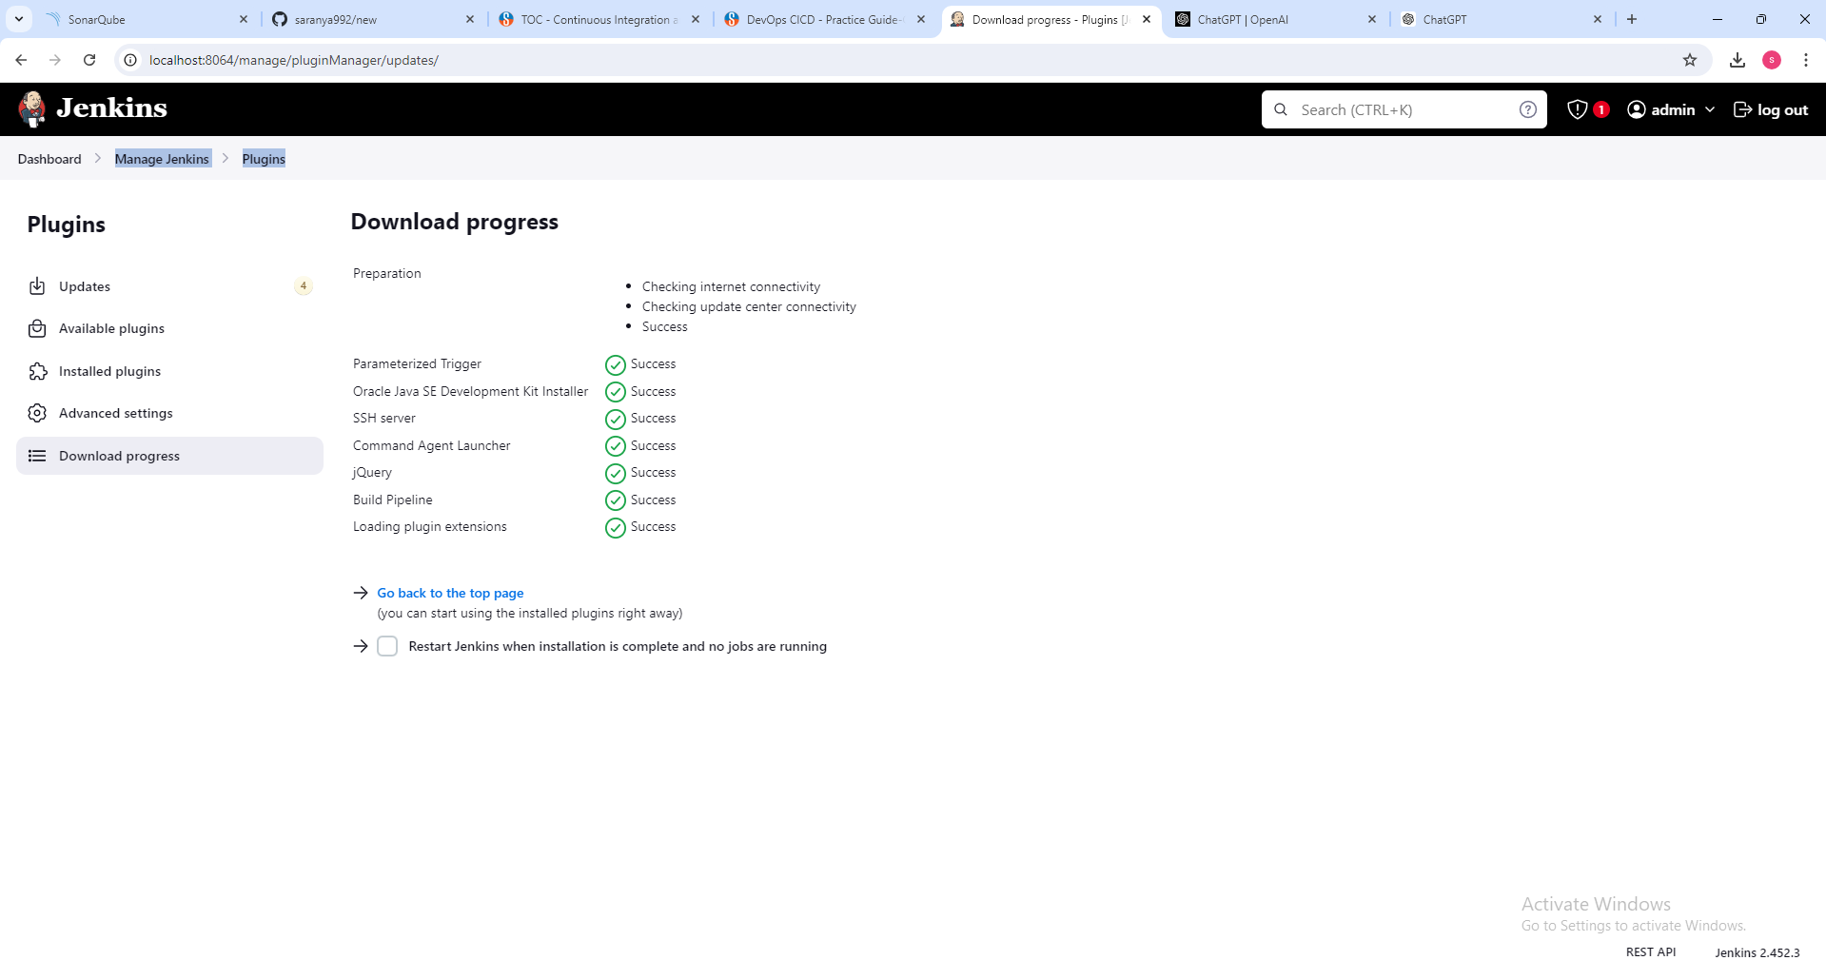
STEP 3:

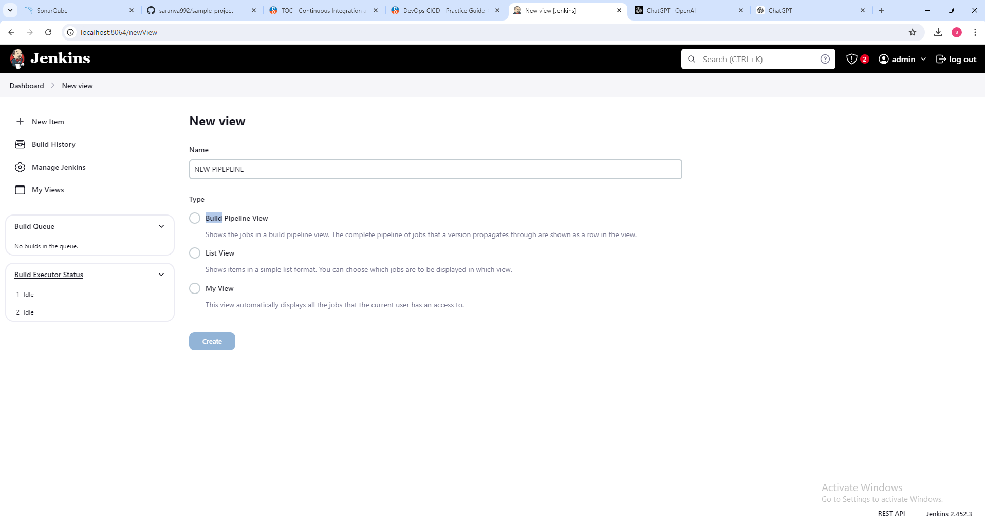

SCROLL DOWN AND CLICK OK-> YOU WILL SEE THE PIPELINE OF PROJECTS WE BUILD BEFORE(REFER EXPERIMENT 11)

Step 4 : Execute the job from setup and you can see the pipeline flow as shown in the screenshot given below.

